How to create a new group in TeamKeeper

Go to Administrator > Group Management

In the middle section under Group Details enter the name of the contract in Description and hit ‘Save’.

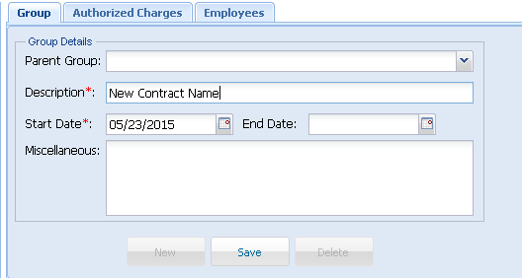

After the new group is created, use the bottom section of the screen to assign the supervisor. Remember: Admin users will be able to see all groups but they will not receive notifications.

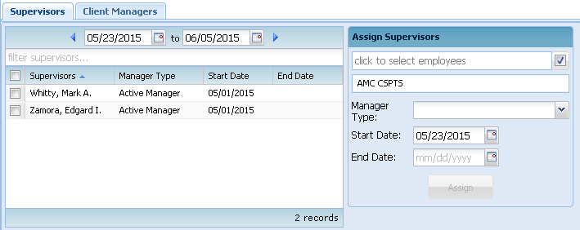

If there will be a new Charge Code for the contract go to Accounting > Charge Code Management and create the charge code.

Go back to Administrator > Group Management and click the Employee tab after selecting the group. On the right side use the box to assign employees to group.

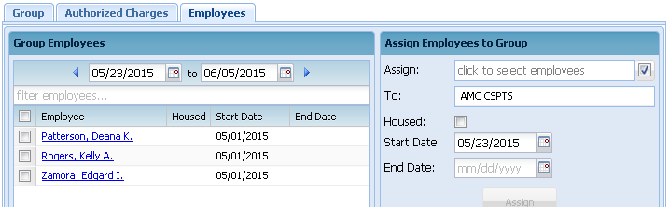

After the employees are entered into the group, go to the Authorized Charges tab in Group Management. To add an authorized charge, use Assign Authorized Charges to Group to select the charge code and pay type combination needed for the contract (don’t add leave, that’s a separate group).