**Pay Stub Viewing Instructions**

Website: https://

Username: firstinitial.lastname (ex: Lisa Jones = ljones)

Default password: same as username

*Please change password after first log in.

**Employee > Pay Stub** – Brings you to your current paystub. The first time you login, you must consent to viewing your paystub by clicking Yes on the displayed statement.

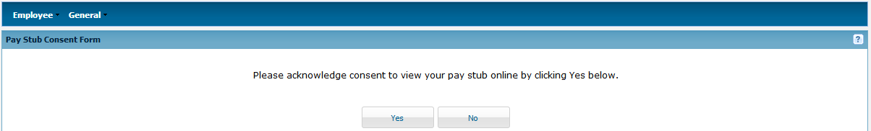

After consent is given, you will be directed to your current pay stub but you can choose previous pay stubs from the drop down menu.

**Employee > Personal Info** – Your profile has been created with your email address. You will receive an email every time a new pay stub is posted. All other fields are optional. If you need to edit the field, make sure to click “Save” at the bottom of the page.

**Employee > Change Password** – Your account is created with a default password. Please change your password after your first log in.

