**Basic Timesheet Instructions**

Website: https://

Username:

Default password:

*Please change password after first log in.

Links available upon login:

* Employee
  + Timesheet
  + Personal Info
  + Change Password
* General
  + Blank Forms
  + Newsletter

**Employee > Timesheet** – Brings you to the current timesheet

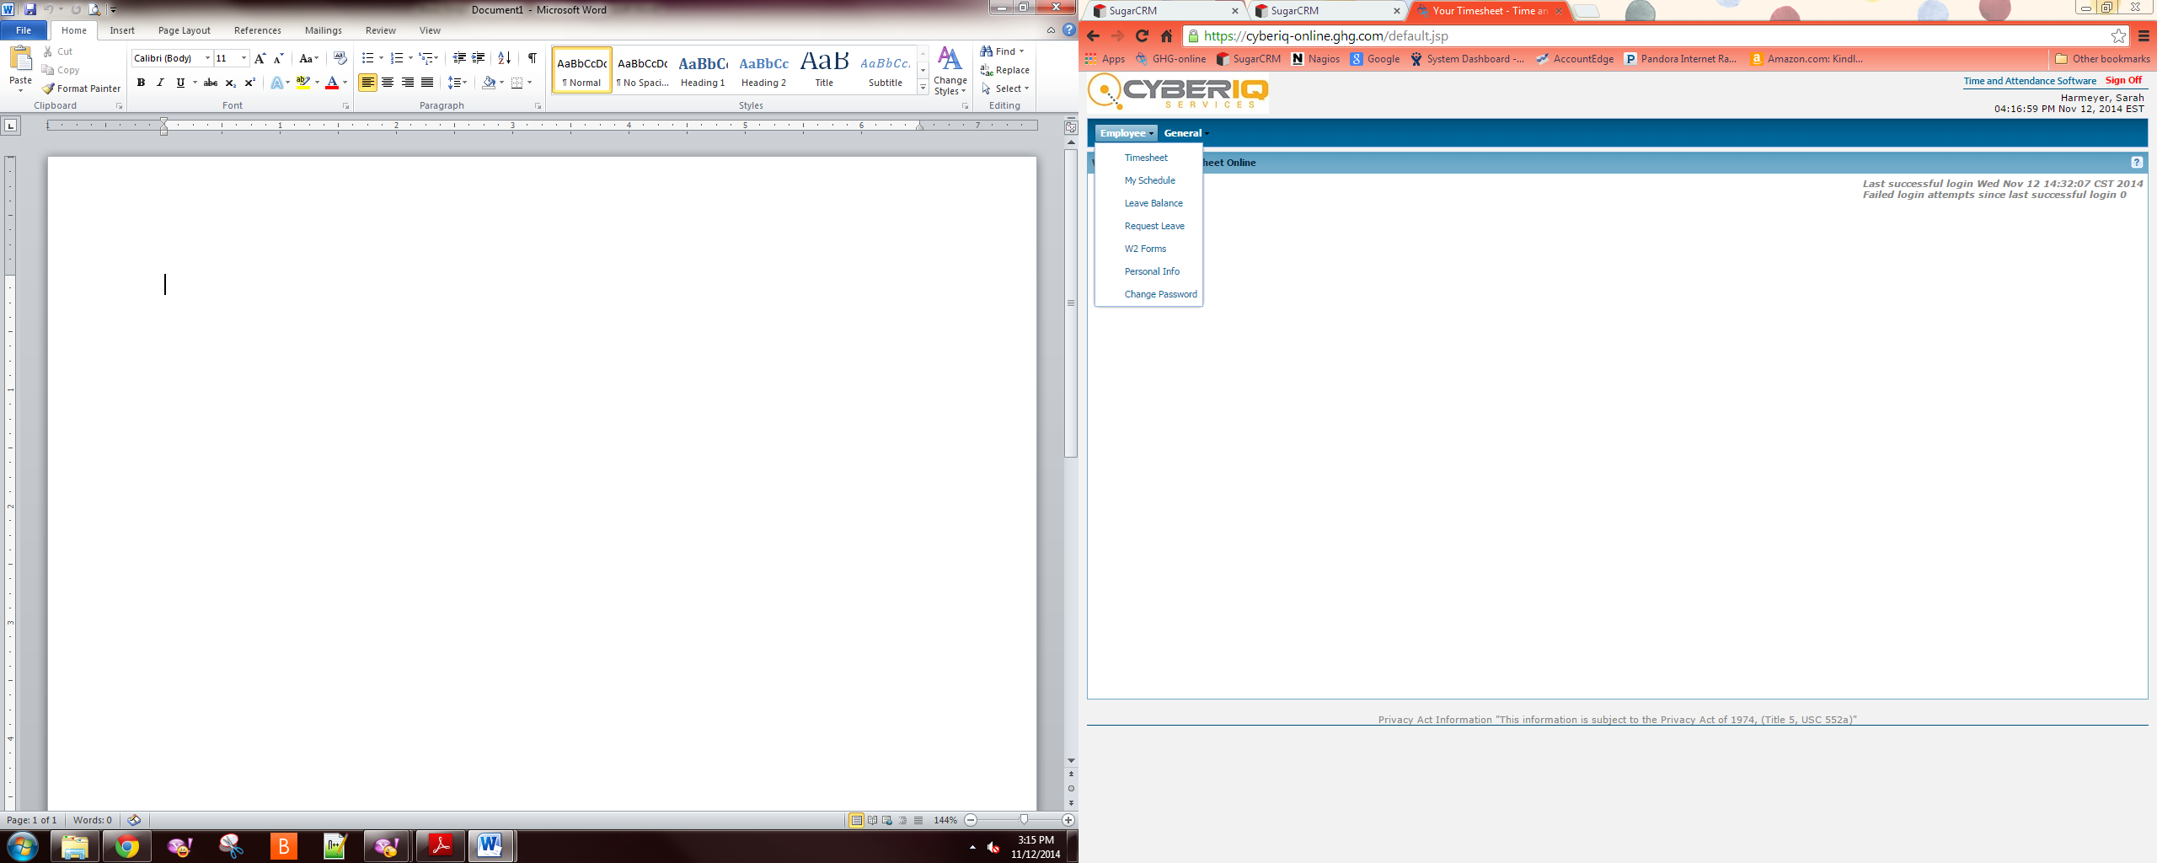

Use the drop down menus under each category to select the item worked on that day.

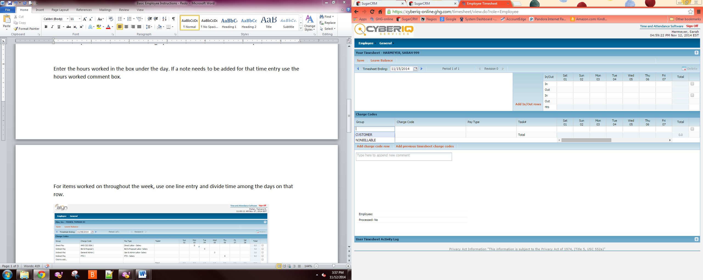

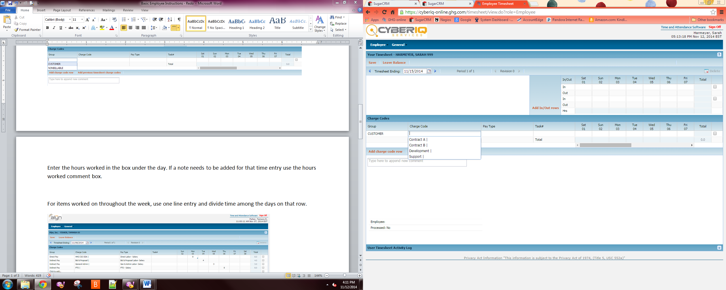

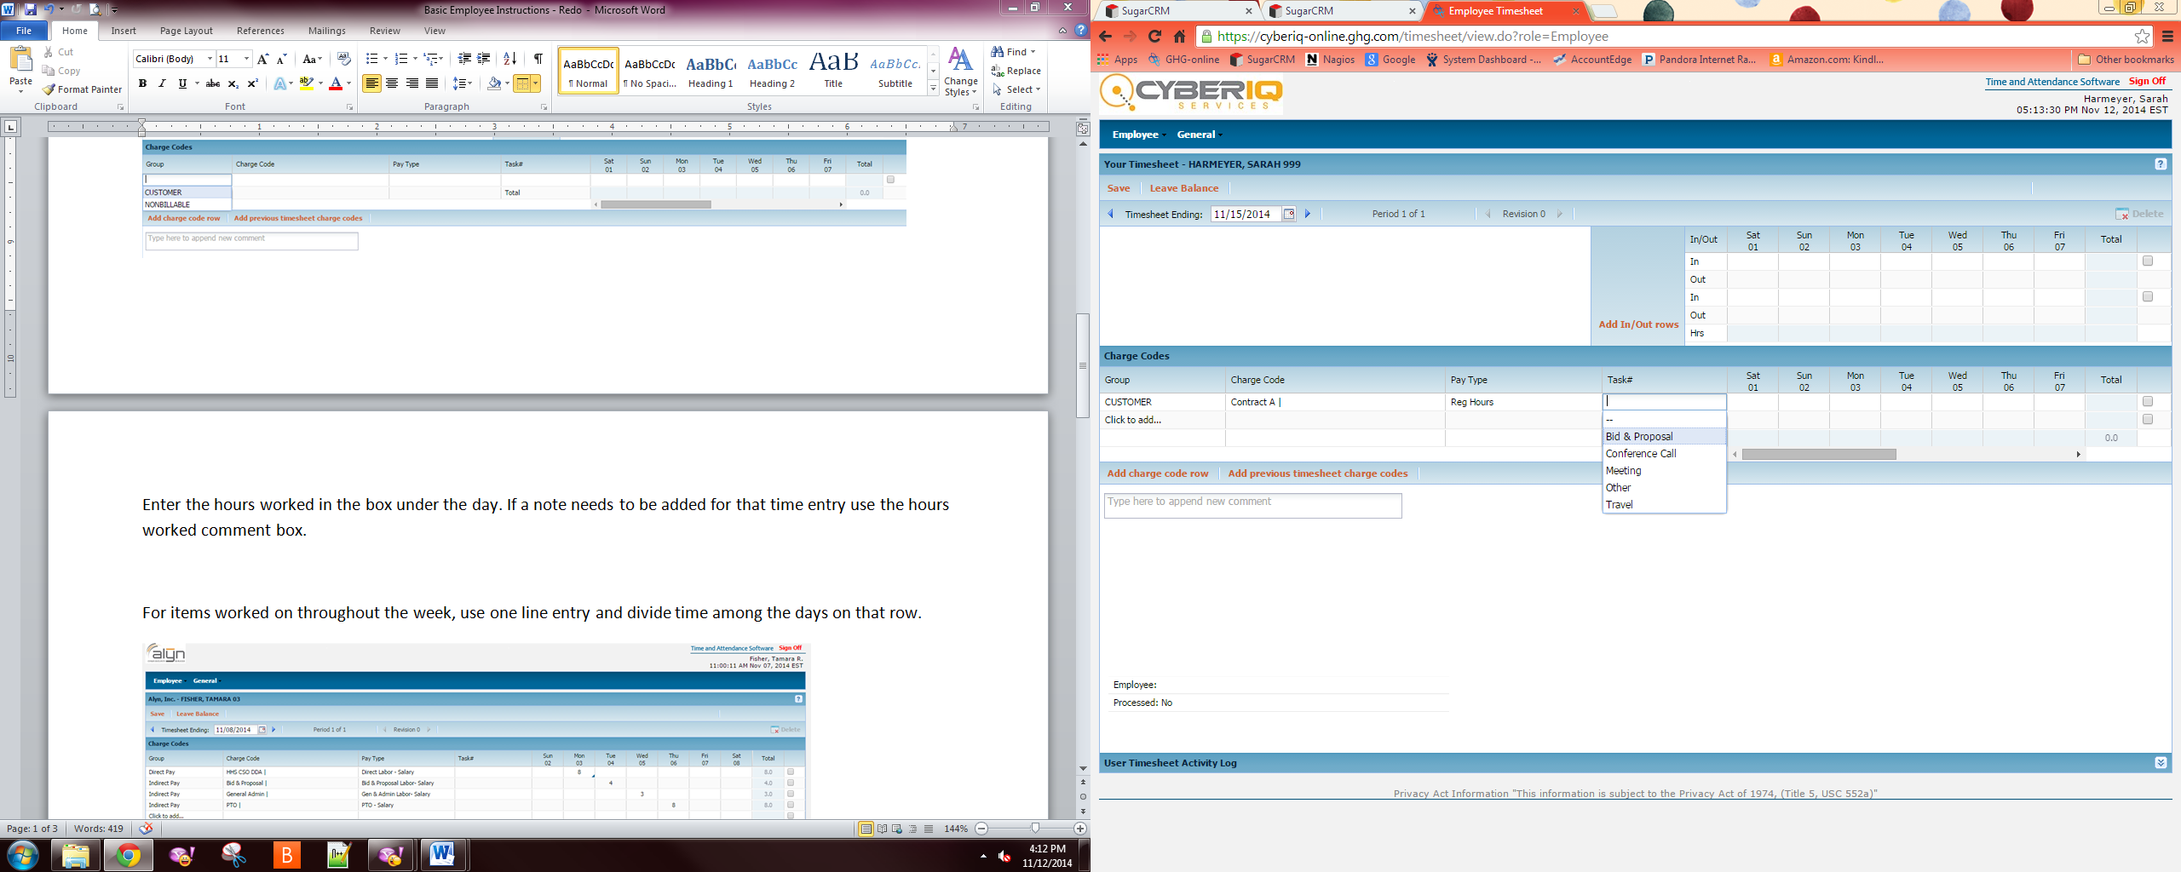

For items worked on throughout the week, use one line entry and divide time among the days on that row.

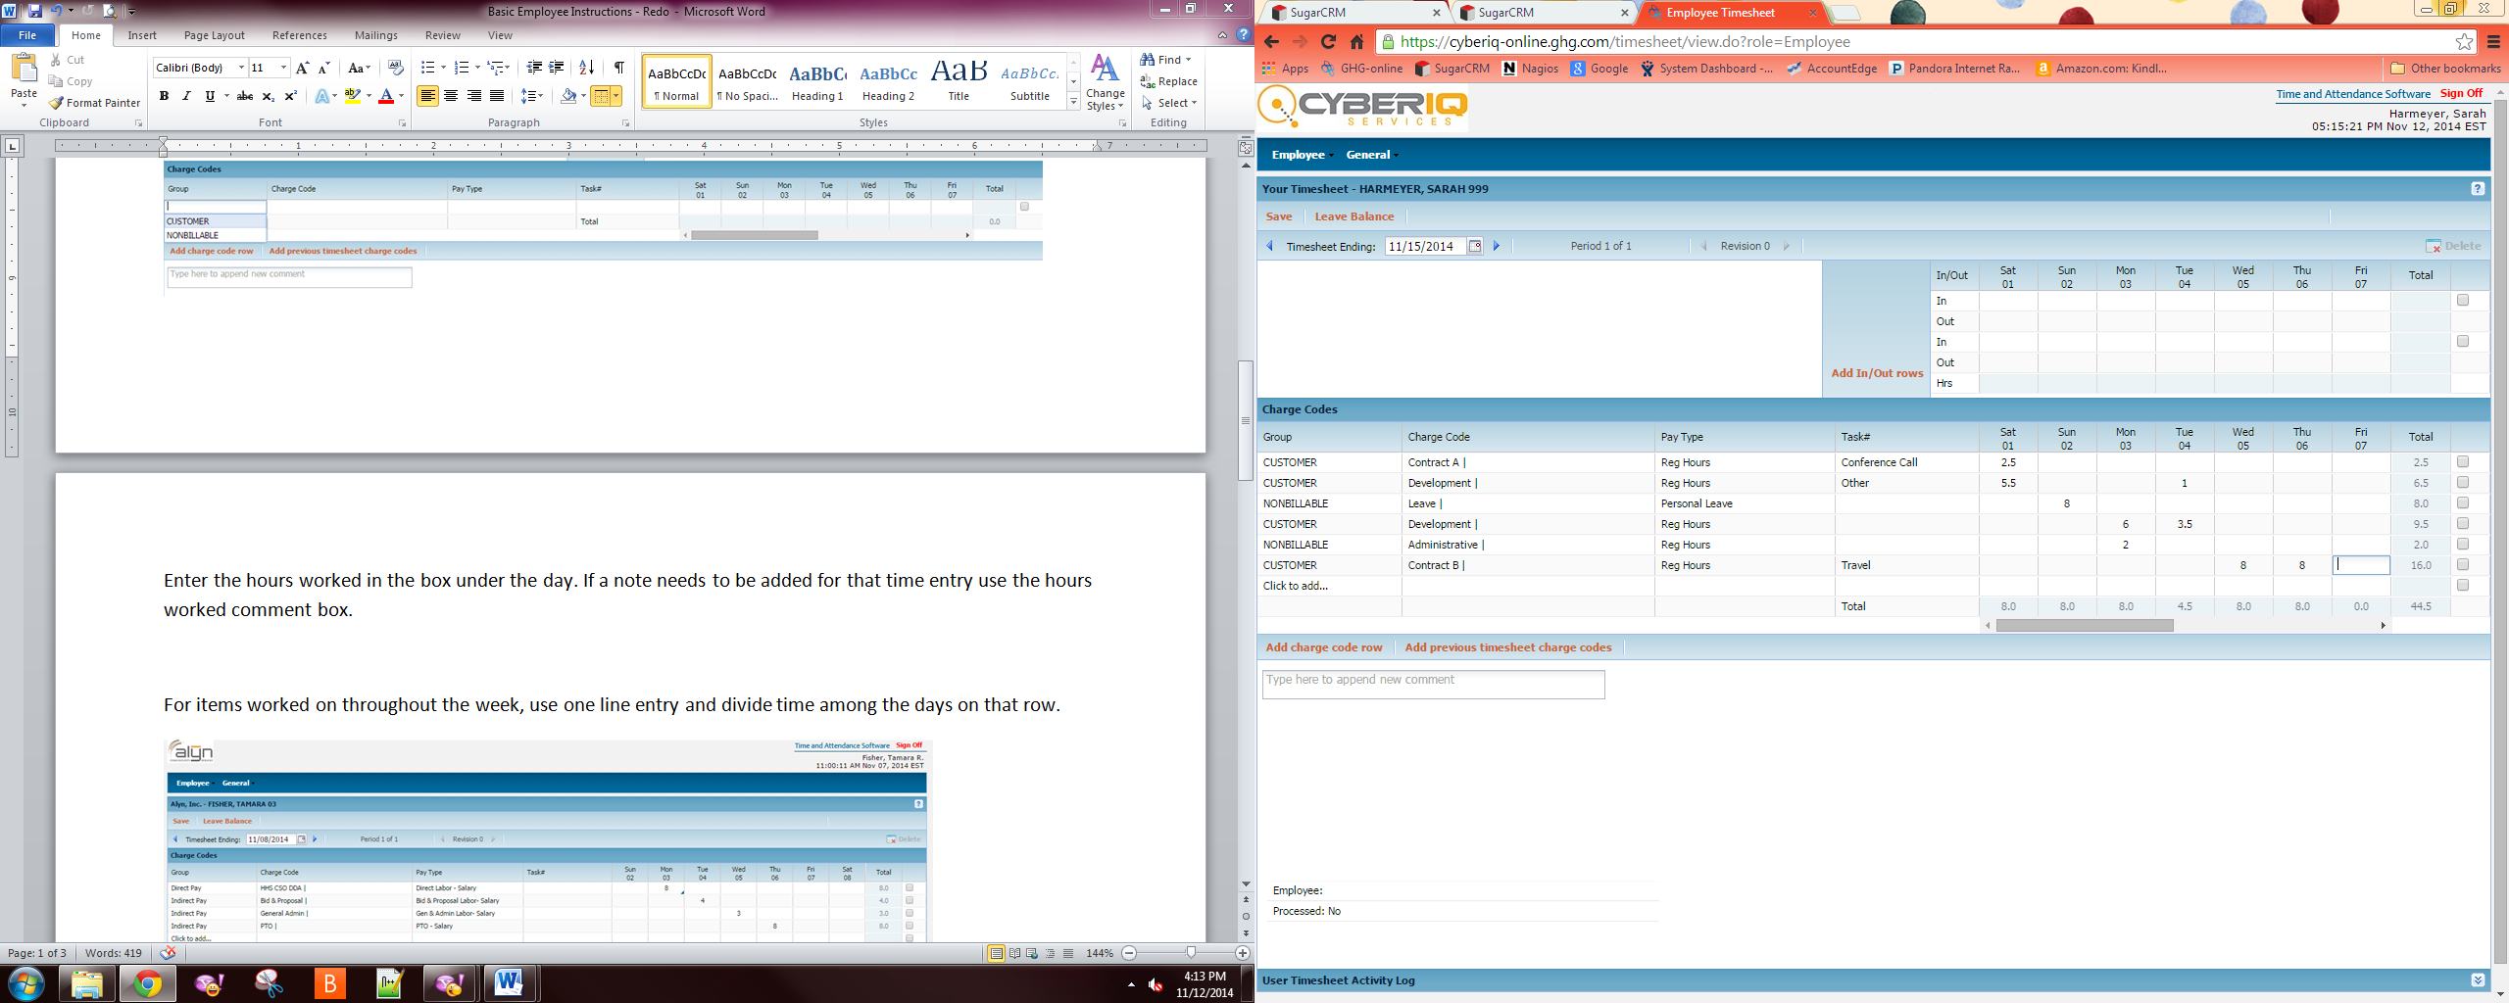

Enter the hours worked in the box under the day. If a note needs to be added for that time entry use the hours worked comment box. Note: This option may not be available for all employees. See administrator for questions.

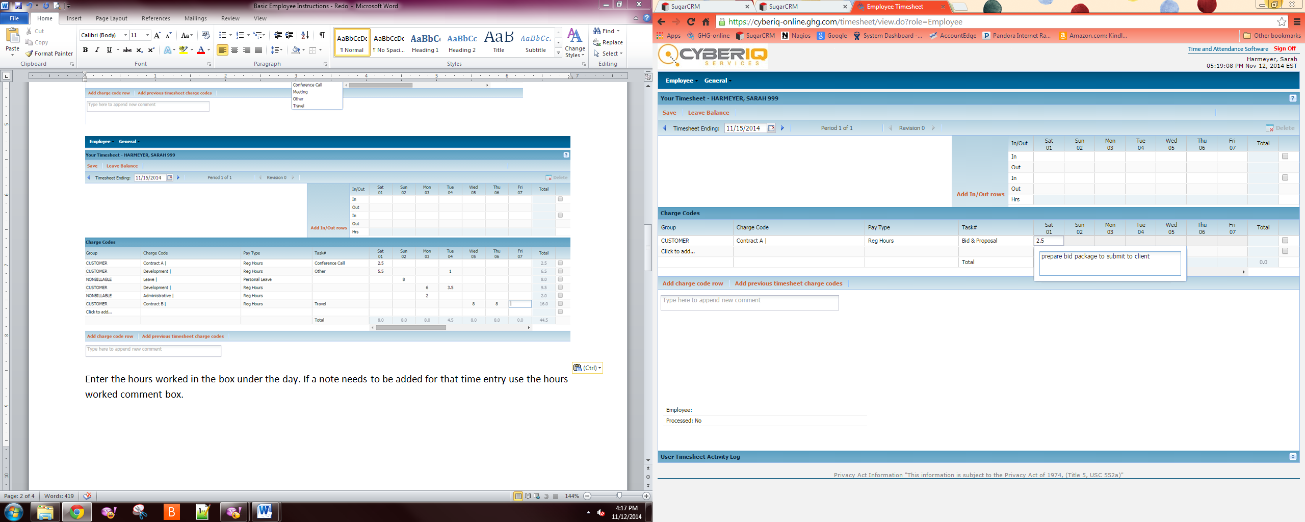

The timesheet comment box is for the entire timesheet period – not a specific day. Multiple comments are allowed. 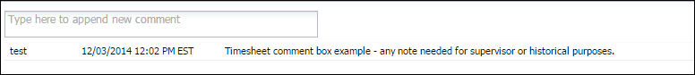

To submit a timesheet choose the Submit button at the top of the screen and answer Yes to the popup box. Your electronic signature will appear at the bottom of the screen along with a date and timestamp. Once your supervisor has approved their electronic signature will appear under the employee line.

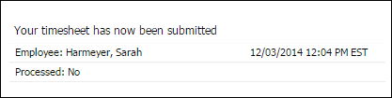

After the timesheet has been saved the menu options at the top will change.

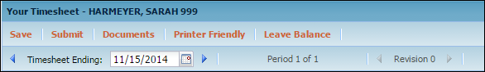

* Save - After each entry hit save. If you are timed out the data will not automatically save.
* Submit - At the end of the timesheet period, use the Submit button to send timesheet to supervisor for approval.
* Documents - If there is any documentation to be submitted with the timesheet (doctor note, jury note, or expense type report) use the button to attach any files.
* Printer Friendly – converts in/outs, timesheet rows, comments and activity log to PDF format.
* If an error is found after submittal or a supervisor rejects your timesheet and request changes, you will be able to unsubmit and make changes. After a supervisor approved and payroll is processed, you will not be able to make any changes to the timesheet (although you can always view and print).

**Employee > Personal Info** – Allows you to update certain information visible to the administrators.

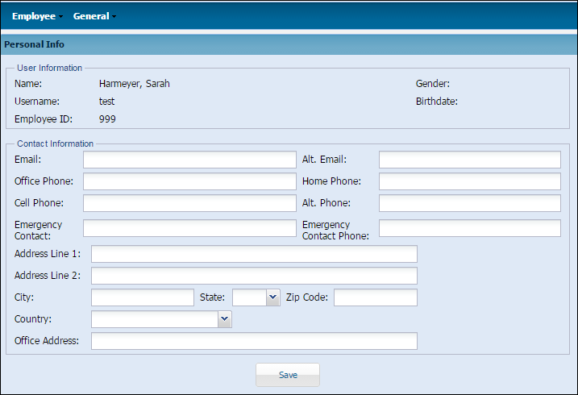

**Employee > Change Password** – Your account is created with a default password. Please change your password after your first log in.

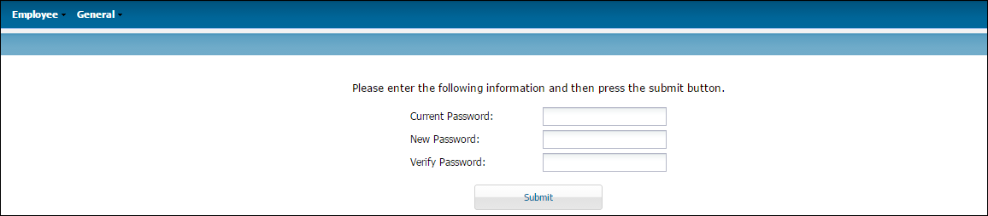

* The General tab allows access to an employee roster, any blank forms or newsletter items the company provides.
* For general help on any page, click the white question mark in the top right corner of the screen.