The first time the import tool is used to import timesheets, you will get this pop-up.

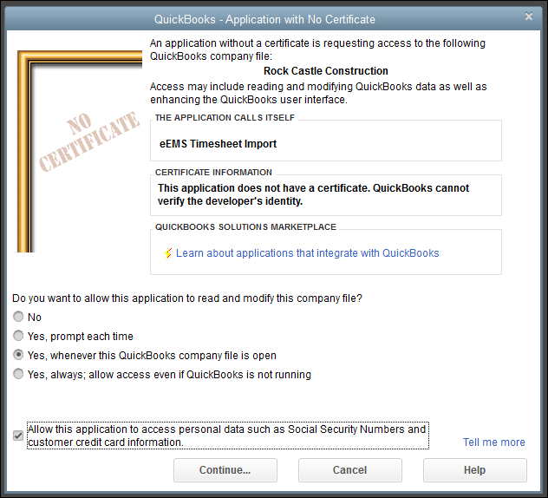

Choose the 3rd and 5th box then “Continue”

Another confirmation box – choose “Yes”

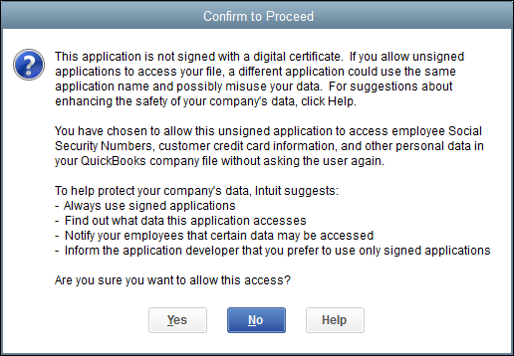

Final confirmation. Once you choose “Done” your hours will start importing.

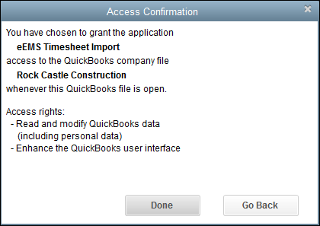

Now that QuickBooks can communicate throught the import tool, it will show up under your preferences. Go to Edit > Preferences > Integrated Applications > Company Preferences and if installed correctly, the tool will be listed like below:

