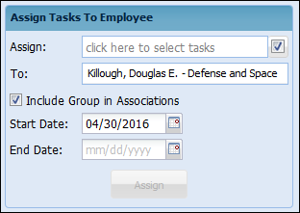

The service items that are not associated to the groups will be blank under the group column.

Once you open the group on the left side panel, choose your name and check the box “Include Groups in Associations”

