Group/Task Association

Go to Accounting > Task Management

All of your currently active tasks will be listed on the left hand side with the option to add new ones in the center console. The bottom middle portion will allow you to assign a selected task (by clicking on the list on the list) to employee(s).

If an employee needs to have access to that task no matter which group is selected:

Click the task on the left side and it will populate under “Assign Task to Employees”

In “Assign:” open groups or View All and select the employee(s)

Do not click the box “Include Groups in Associations”

Change the start and end dates as needed

Click “Assign”

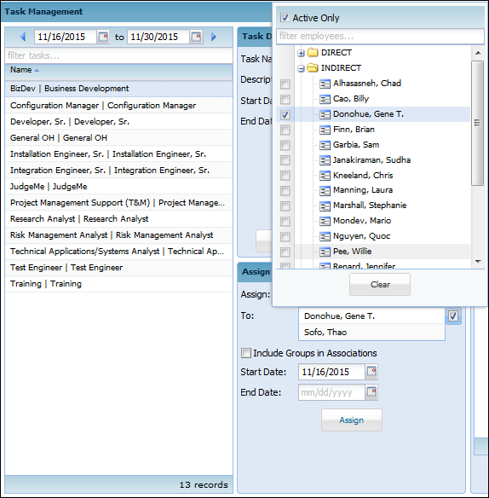

If an employee needs to have access to that task dependent on which group is selected:

Click the task on the left side and it will populate under “Assign Task to Employees”

In “Assign:” open groups and select the employee(s)

**Click the box “Include Groups in Associations” **You will notice the group name after the employee name\*\***

Change the start and end dates as needed

Click “Assign”

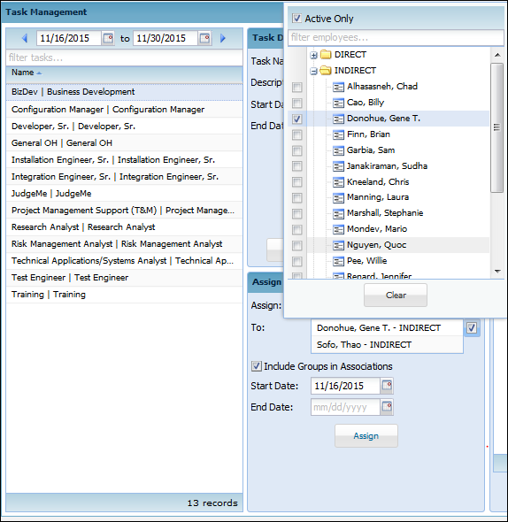

**Setup Tip:**

MULTIPLE tasks to ONE employee – Administrator > Employee Management > Task

ONE task to MULTIPLE employees – Accounting > Task Management